**PROCESS OF CREATING VIRTUAL MACHINE**

**1.LOGIN TO THE AZURE ACCOUNT PORTAL**

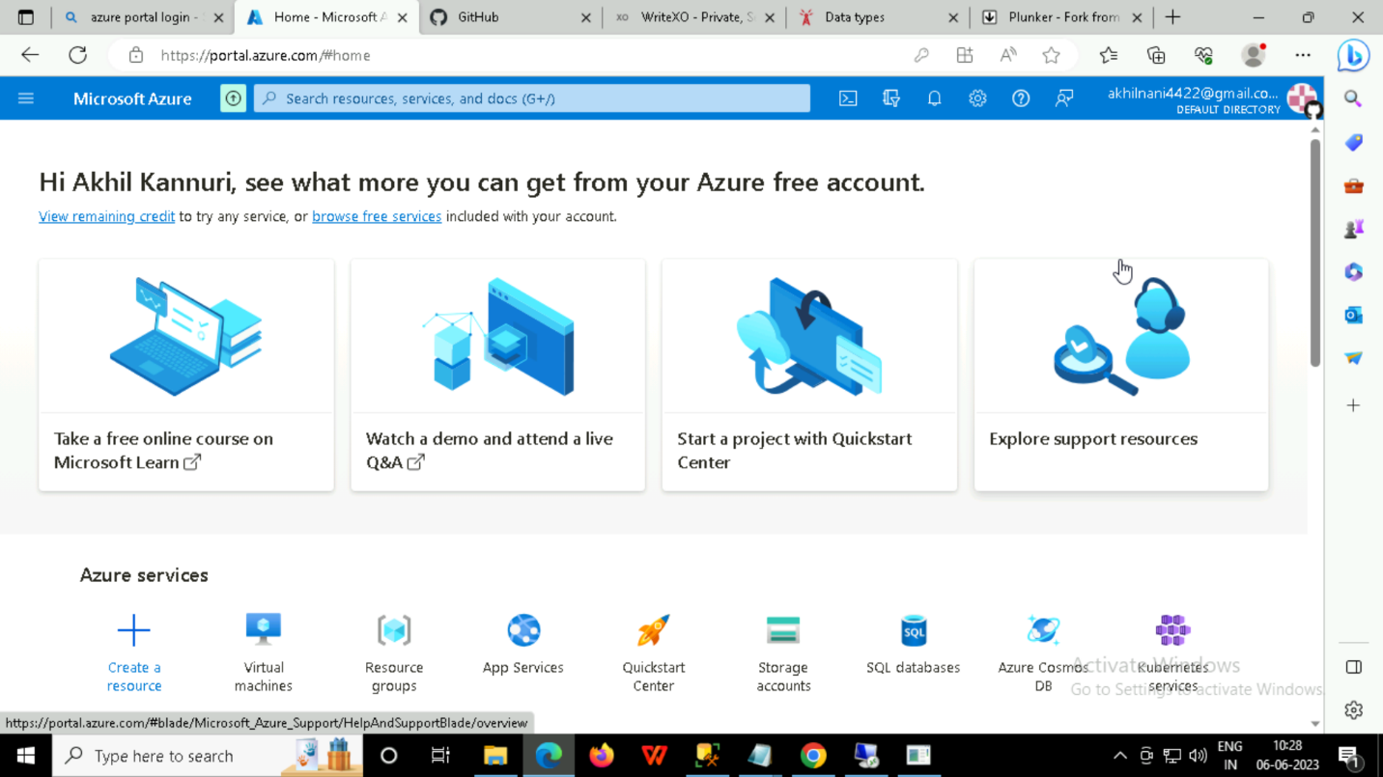

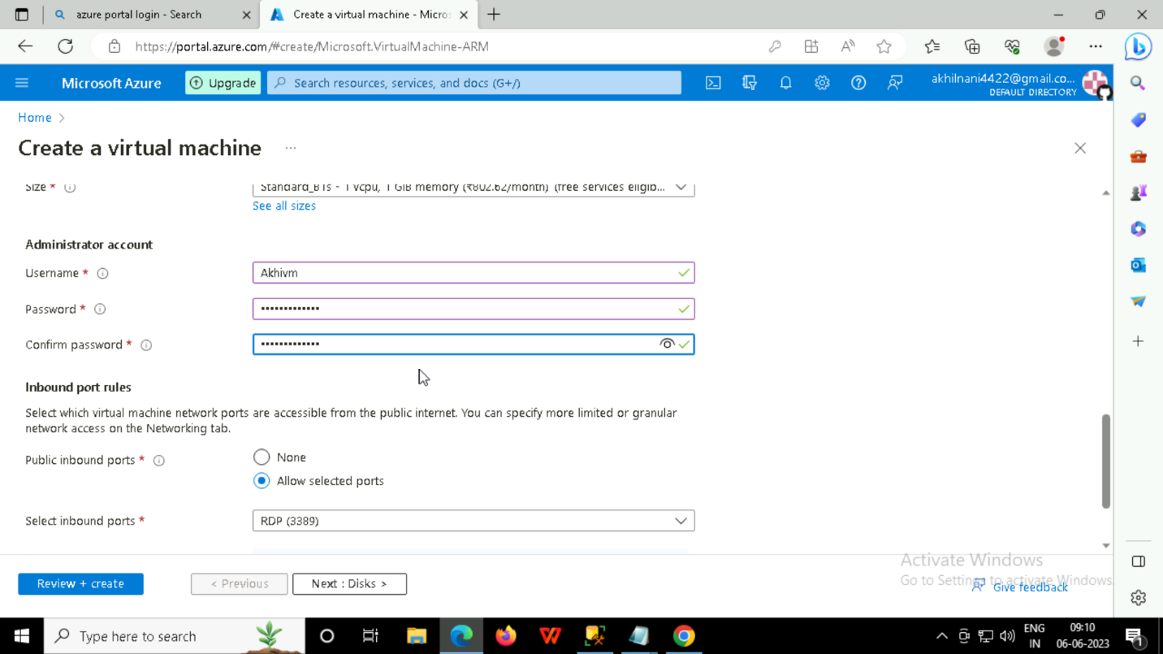

**HERE THR PROCESS THAT YOU CAN FOLLOW THE STEPS:**

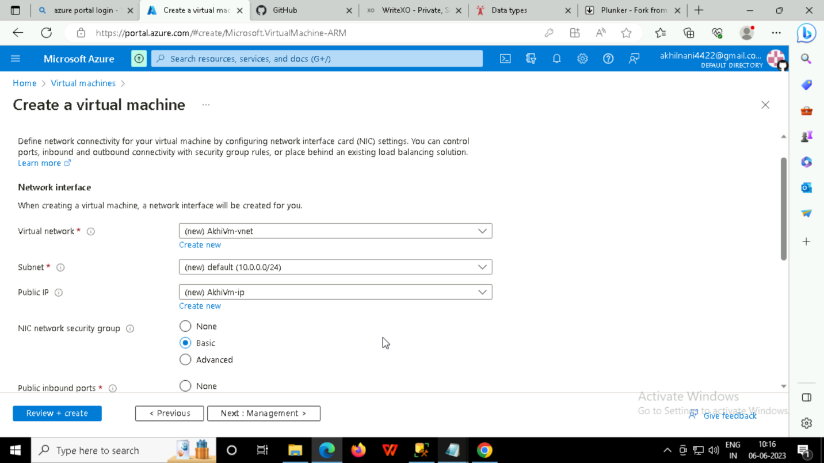

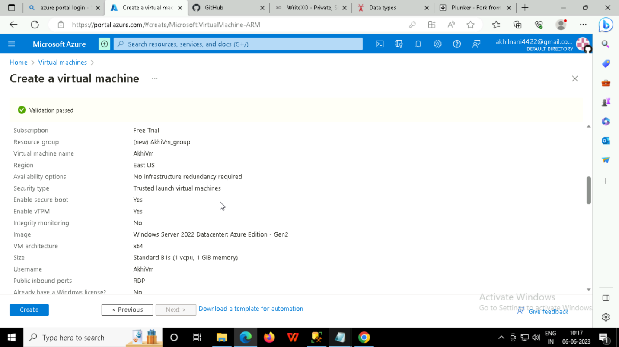

**AFTER CLICK THE ‘BUTTON’ CREATE THEN FOLLOW THE STEPS :**

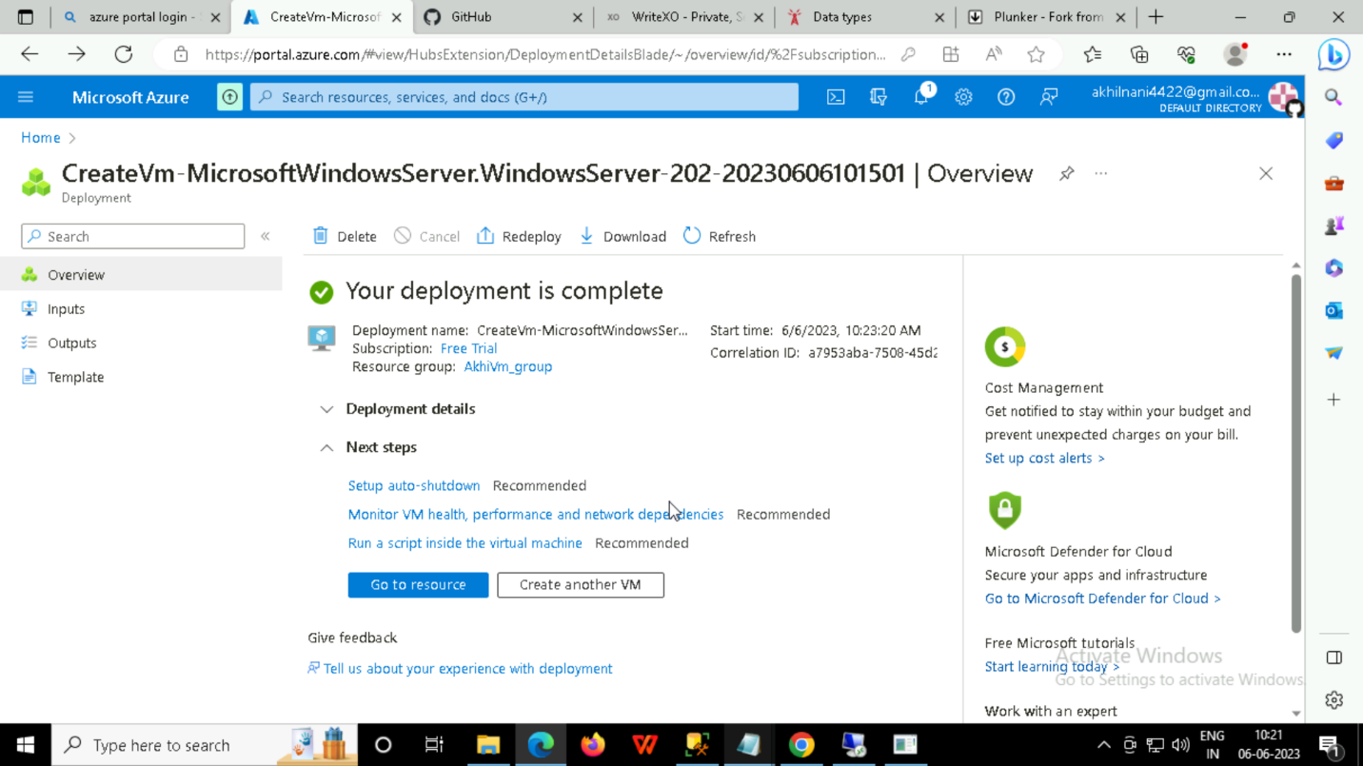

**THEN CLICK THE RESOURCE BUTTON:**

**THEN DOWNLOAD THE RDP FILE AND RUN THE APPLICATION:** 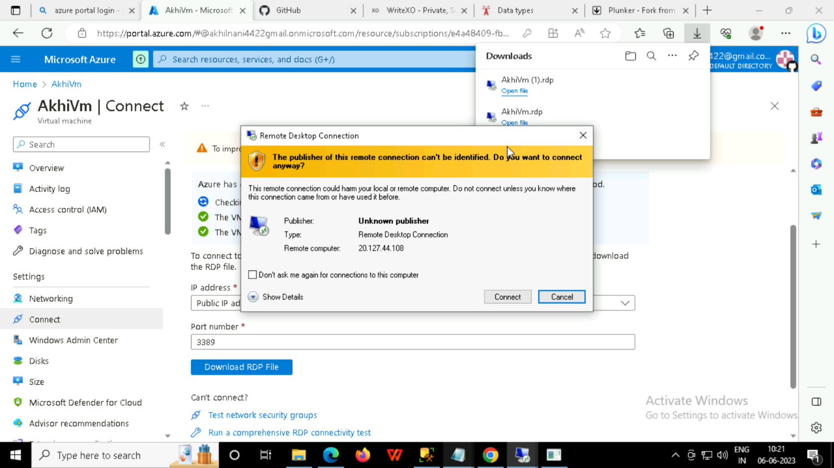

**AFTER CONNECT TO THE APPLICATION:**

**ENTER THE USERNAME AND PASSWORD THAT YOU HAVE CREATED**

**AFTER ENTERING THE USERNAME AND PASSWORD YOU CAN CONNECT TO THE VM:**

**NOW, WE ARE SUCESSFULLY CREATED VM :**

